**SAMPLES OF WORK OUTPUT WITH SUPERVISOR’S SIGNATURE**

[**https://drive.google.com/file/d/1oQ8iKwGzcKUVtZhZcSMXTsO34rA2BOi3/view?usp=sharing**](https://drive.google.com/file/d/1oQ8iKwGzcKUVtZhZcSMXTsO34rA2BOi3/view?usp=sharing)

[**https://drive.google.com/file/d/1nJVqqfWjvz9YVWocljqr6Q1xqudck9FA/view?usp=sharing**](https://drive.google.com/file/d/1nJVqqfWjvz9YVWocljqr6Q1xqudck9FA/view?usp=sharing)

[**https://drive.google.com/file/d/1PoMXRw2hu6xEk9EvqcsoJjE5u8iJ9TC4/view?usp=sharing**](https://drive.google.com/file/d/1PoMXRw2hu6xEk9EvqcsoJjE5u8iJ9TC4/view?usp=sharing)

[**https://drive.google.com/file/d/1qyHCzQetQO5sR217XgMGvz1qKKQI4gJQ/view?usp=sharing**](https://drive.google.com/file/d/1qyHCzQetQO5sR217XgMGvz1qKKQI4gJQ/view?usp=sharing)

* **FLYER**

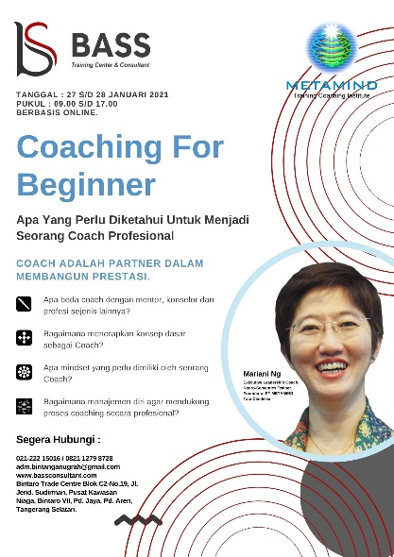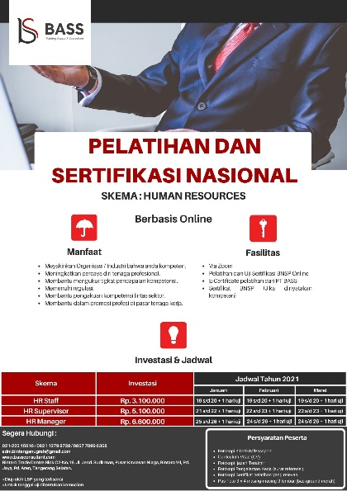

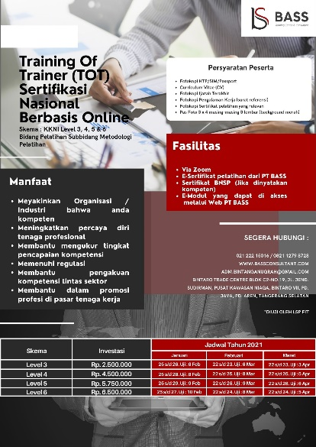

Jakarta, 21 Desember 2020

Yang Bertanda Tangan Dibawah Ini,



Rahayu Wibowo

Supervisor